**E-BOOKOPOLIS**

**A PROJECT REPORT**

***Submitted by***

**SRIJA CHATTOPADHYAY (21BCE10401)**

*in partial fulfillment for the award of the degree*

*of*

**BACHELOR OF TECHNOLOGY**

*In*

COMPUTER SCIENCE AND ENGINEERING



**SCHOOL OF COMPUTING SCIENCE AND ENGINEERING**

**VIT BHOPAL UNIVERSITY**

**KOTHRIKALAN, SEHORE**

**MADHYA PRADESH – 466114**

FEBRUARY 2023

**I**

**VIT BHOPAL UNIVERSITY,KOTHRIKALAN, SEHORE**

**MADHYA PRADESH – 466114**

**BONAFIDE CERTIFICATE**

Certified that this project report titled **“E-BOOKOPOLIS”** is the bonafide work of **SRIJA CHATTOPADHYAY (21BCE10401), ANUSHMITA AICH (21BCE10080), SRISTEE CHAUDHARY (21BCE10416), RISHITA RAI (21BCE11090)**  who carried out the project work under my supervision. Certified further that to the best of my knowledge the work reported here does not form part of any other project / research work on the basis of which a degree or award was conferred on an earlier occasion on this or any other candidate.

**PROJECT SUPERVISOR**

Dr Kamlesh Chandravanshi

School of Computer Science and Engineering

VIT BHOPAL UNIVERSITY

The Project Exhibition I Examination is held on _______________

**II**

**ACKNOWLEDGEMENT**

First and foremost I would like to thank the Lord Almighty for His presence and immense blessings throughout the project work.

I wish to express my heartfelt gratitude to Dr Sandip Mal ,Head of the Department, School of Computer Science for much of his valuable support encouragement in carrying out this work.

I would like to thank my internal guide Mr Kamlesh Chandravanshi ,for continually guiding and actively participating in my project, giving valuable suggestions to complete the project work.

I would like to thank all the technical and teaching staff of the School of Aeronautical Science, who extended directly or indirectly all support.

Last, but not the least, I am deeply indebted to my parents who have been the greatest support while I worked day and night for the project to make it a success

**III**

**LIST OF FIGURES**

|  |  |  |
| --- | --- | --- |
| **FIGURE NO.** | **TITLE** | **PAGE NO.** |
| **1.** | FOR ADMIN | **4** |
| **2.** | FOR USER | **4** |
| **3.** | LOGIN PAGE | **5** |
| **4.** | REGISTRATION PAGE | **5** |
| **5.** | HOME PAGE | **6** |
| **6.** | REVIEW PAGE | **6** |
| **7.** | UPLOAD PAGE | **6** |
| **8.** | BLOG/POST PAGE | **7** |
| **9.** | USER ACCOUNT PAGE | **7** |
| **10.** | CONTACT PAGE | **7** |
| **11.** | ABOUT PAGE | **8** |

**IV**

**LIST OF TABLES**

|  |  |  |
| --- | --- | --- |
| **TABLE NO.** | **TITLE** | **PAGE NO.** |
| **1.** | PERFORMANCE MEASURES | **9** |

**V**

**ABSTRACT**

The primary objective of our project to create a website which allow its users to discuss about different types of books, read books for free and upload poems or stories written by them to gain recognition and publisher attention.

**VI**

**TABLE OF CONTENTS**

|  |  |  |
| --- | --- | --- |
| **CHAPTER NO.** | **TITLE** | **PAGE NO.** |
|  | List of Figures  List of Tables  Abstract | **IV**  **V**  **VI** |
| **1** | **INTRODUCTION**     * 1. Introduction      * 1. Problem Statement     1.3 Objective of the work | **1** |
| **2** | **LITERATURE SURVEY**  2.1 Introduction  2.2 Research issues/observations from  literature Survey | **2** |
| **3** | **SYSTEM ANALYSIS**  3.1 Introduction  3.2 Disadvantages/Limitations in the existing system  3.3 Proposed System | **3** |
| **4** | **SYSTEM DESIGN AND IMPLEMENTATION**    4.1 Introduction  4.2 Module design & implementation | **4 - 8** |
| **5** | **PERFORMANCE ANALYSIS**  5.1Introduction  5.2 Performance Measures (Table) | **9** |
| **6** | **FUTURE ENHANCEMENT AND CONCLUSION**  6.1Introduction  6.2 Limitation/Constraints of the System  6.3 Future Enhancements  References | **10** |

**CHAPTER 1- INTRODUCTION**

**CHAPTER 1.1- INTRODUCTION**

E-Bookopolis is a website which allow its Users to discuss about different types of books, read books for free and can upload poems or stories written by them to gain recognition and publisher

attention. Upload poems or stories written by them to gain recognition and publisher attention

**CHAPTER 1.2 - PROBLEM STATEMENT**

Design a website which should allow users to discuss different types of books, read books for free and can upload poems or stories written by them.

**CHAPTER 1.3 – OBJECTIVE**

To design a website which allow its Users to discuss about different types of books, read books for free and can upload

Poems or written by them to gain publisher attention**.**

**1**

**CHAPTER 2 - LITERATURE REVIEW**

**CHAPTER 2.1 - INTRODUCTION**

Reading is good for people. Reading books in particular. Time and time again,

research has shown that people who read books are better informed than people

who do not and are consequently better able to hold their own in society. They

are more aware of their surroundings and can envisage themselves more easily

in other people’s place. They are more capable of reflecting on their own

conduct and on that of others. Reading books lets them acquire a wide range of

skills that also make them stand out on the work floor. In fact, reading books

even helps make them more healthy: firstly because people who read books are

better informed about topics such as health risks and access to care, and

secondly because reading books has a positive effect on the brain.

**CHAPTER 2.2 – RESEARCH ISSUES**

According to a survey the reading habits of people in 17 countries, 30% of people read books every day (or most days) and 60% read at least once per week.

In the U.S. 73% of the population reads at least one book per year. Another survey tells us that people in India read the most and spend an average of 10 hours and 42 minutes reading per week. Thailand (9 hours and 24 minutes) and China (8 hours) came in second and third. The U.S. and Germany ranked 21st

**2**

and 22nd respectively with each averaging 5 hours and 42 minutes of reading per week.

**CHAPTER 3 - SYSTEM ANALYSIS**

**CHAPTER 3.1 - INTRODUCTION**

As mentioned above our aim is to develop a website which will allow the users to discuss different types of books, read books for free and can upload poems or stories written by them.

**CHAPTER 3.2 - DISADVANTAGES AND LIMITATIONS**

Due to constraint of time, it is clear that there are disadvantages and limitations in this project.

* There might be some flaws in security of the website.
* Secondly, we have not implemented login using existing account such as google account, Apple Id etc.
* Absence of other essential features

**CHAPTER 3.3 - PROPOSED SYSTEM**

E-Bookopolis is a website that allows users to read ,discuss and upload stories and poems written by them.

**3**

**CHAPTER 4 - SYSTEM DESIGN AND IMPLEMENTATION**

**CHAPTER 4.1- INTRODUCTION**

PROCESS FLOW FOR ADMIN-

Once the user logins he can perform functions view user, view publisher , view book and add publisher.

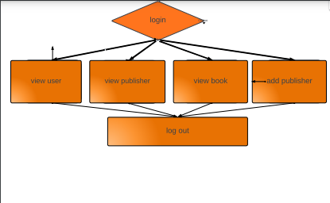

Figure 1

PROCESS FLOW FOR USER

The user will also login and perform functions like search book by preference can like comment and share uoload and delete book and view rating and give feedback.

**4**

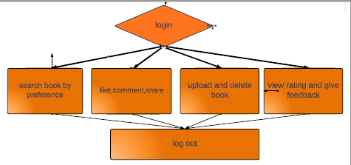

Figure 2

**CHAPTER 4.2 - MODULE DESIGN**

LOGIN PAGE - used by the user to login into website.

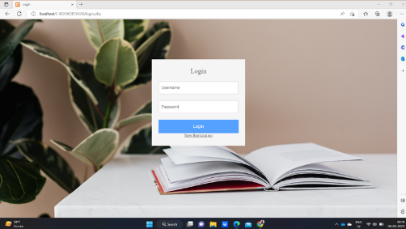

Figure 3

REGISTRATION PAGE - performed by all users to register new user to create account

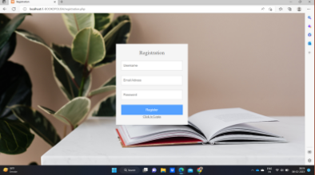

Figure 4

**5**

HOME PAGE - the main dashboard which is accessed after registration and login.

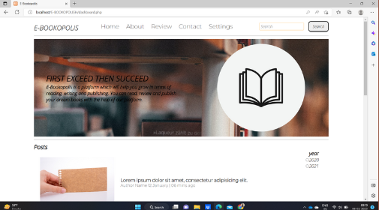

Figure 5

REVIEW PAGE - the main dashboard which is accessed after registration and login.

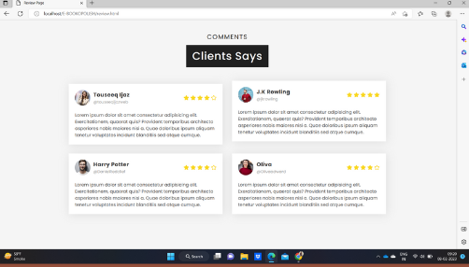

Figure 6

UPLOAD PAGE - this feature lets the user to upload his book or any blog

**6**

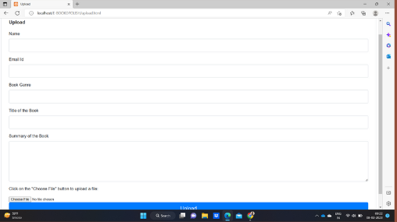

Figure 7

BLOG/POST PAGE - this page opens up each individual post respectively.

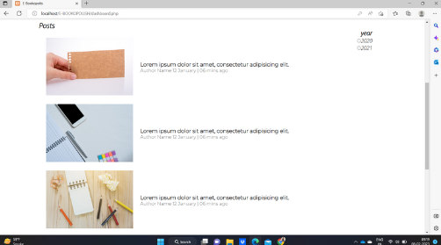

Figure 8

USER ACCOUNT PAGE - the main profile page of the user.

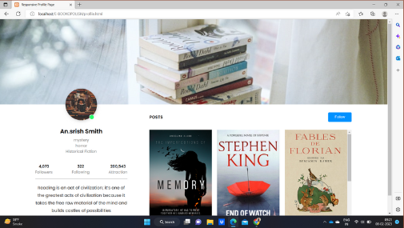

Figure 9

CONTACT PAGE - Page through which user can contact us.

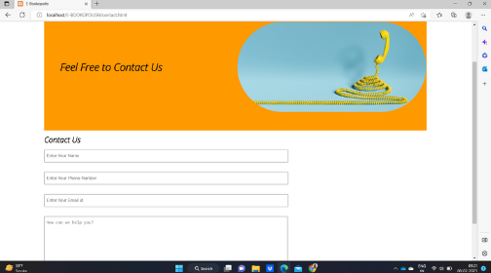

Figure 10

ABOUT PAGE - This page tells what our website is about

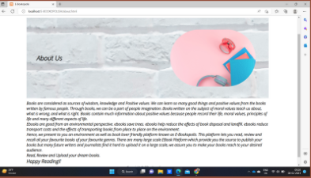

Figure 11

**CHAPTER 4.3 - MODULE IMPLEMENTATION**

* Users have to first login to the website.
* They can search any book by preference.
* They can like comment and share.
* They can also upload there own write ups
* They can also view rating and give feedback

**8**

**CHAPTER 5 - PERFORMANCE ANALYSIS**

**CHAPTER 5.1 – INTRODUCTION**

In order for the website to work properly we need to analyze its performance first.

**CHAPTER 5.2 - PERFORMANCE MEASURES**

FUNCTIONALITY: Log in to the System

EXPECTED OUTCOME: The user should not login to member’s area

. and some error message follow.

|  |  |  |
| --- | --- | --- |
|  | Data Used | Actual Outcome |
| 1. | Click on the log in button  without entering username or password | An alert message came to enter  username |
| 2. | Click on the log in button  after entering some username leaving password field blank | An alert message came to enter  password |
| 3. | Click on the log in button  after entering some password but leaving username field blank | An alert message came to enter  username |
| 4, | Click on the log in button  after entering some wrong username but correct password | A message displayed on Log in  page about this |
| 5. | Click on the log in button  after entering some wrong password but correct username | A message displayed on Log in  page about this |

**9**

**CHAPTER 6 - FUTURE ENHANCEMENTS AND CONCLUSIONS**

**CHAPTER 6.1- LIMITATIONS OF THE SYSTEM**

* There might be some flaws in security of the website.
* Secondly, we have not implemented login using existing account such as google account, Apple Id etc.
* Absence of other essential features

**CHAPTER 6.2 - FUTURE ENHANCEMENT**

* Improving the security of the website.
* Adding other essential features.

**CHAPTER 6.3 - REFERENCES**

1. Web Design with HTML, CSS by Jon Duckett
2. Codrops CSS Reference

**10**